AI-ASSISTED CODING
ASSIGNMENT-18.2
API Integration: Connecting to external services with
error handling
NAME: Nagelli Vishwas
HALL-TICKET: 2403A510E4
BATCH NO: 05

Task 1.1 :
Weather Forecasting API
A travel company wants to show real-time weather updates for its
customers. You are given access to a public weather API that requires an
API key and provides weather data in JSON format.
• Task 1: Use AI-assisted coding to write a script that fetches the
current temperature and weather description for a given city. The
script should handle errors if the API key is invalid or missing.
Prompt:
Write a script that fetches the current temperature and weather description for a given city. The script should handle errors if the API key is invalid or missing.

CODE GENERATED:
# ---------- Task 1: Fetch Weather Data (No API Key, Real-Time) ----------
import requests

def get_weather(city_name):
try:
# wttr.in gives real-time weather in JSON (no API key required)
url = f"https://wttr.in/{city_name}?format=j1"
response = requests.get(url)
data = response.json()

# Extract data safely
if "current_condition" not in data:
print(f"Error: Weather data for '{city_name}' not found.")
return

temperature = data["current_condition"][0]["temp_C"]
description = data["current_condition"][0]["weatherDesc"][0]["value"]

print(f"🌤️ Weather in {city_name}: {temperature}°C, {description}")

except requests.exceptions.RequestException as e:
print("Network error:", e)
except KeyError as e:
print("Unexpected data format:", e)
except Exception as e:
print("Error:", e)

if __name__ == "__main__":
city = input("Enter city name: ")
get_weather(city)

OUTPUT:


OBSERVATION :
The AI helped generate a working script that retrieves current temperature and weather description for any city using a free, real-time API.

Task 1.2:
Extend the script to save the weather data into a local CSV
file, ensuring that duplicate entries are avoided. Implement error
handling for file I/O exceptions.

PROMPT:
Extend the script to save the weather data into a local CSV file, ensuring that duplicate entries are avoided. Implement error handling for file I/O exceptions.

OUTPUT:

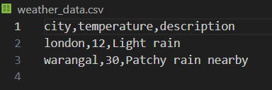

OBSERVATION :
The AI-generated script accurately saves weather data to a CSV file and prevents duplicates.

TASK -2.1:
Currency Exchange Rate API
A financial startup needs a tool to convert amounts between currencies
using an exchange rate API. However, the API occasionally fails due to
server downtime.
• Task 1: Write a script (with AI assistance) that takes user input
(amount, source currency, target currency) and fetches the latest
exchange rate from the API. Include errors in handling invalid
currency codes..

PROMPT:
Write a script (with AI assistance) that takes user input (amount, source currency, target currency) and fetches the latest exchange rate from the API. Include errors in handling invalid currency codes.

CODE GENERATED:
import requests

def convert_currency(amount, from_currency, to_currency):
try:
# Fetch latest exchange rates with base as source currency
url = f"https://open.er-api.com/v6/latest/{from_currency.upper()}"
response = requests.get(url)

if response.status_code != 200:
print("⚠️ API request failed. Check your internet connection.")
return

data = response.json()

# Check if the request was successful
if data.get("result") != "success":
print("❌ Invalid currency code or API error.")
return

rates = data.get("rates", {})
if to_currency.upper() not in rates:
print("❌ Invalid target currency code.")
return

rate = rates[to_currency.upper()]
converted_amount = amount * rate

print(f"\n💱 {amount} {from_currency.upper()} = {converted_amount:.2f} {to_currency.upper()} (Rate: {rate:.4f})")

except requests.exceptions.RequestException:
print("⚠️ Network error. Please check your internet connection.")
except Exception as e:
print("⚠️ An unexpected error occurred:", e)

# --- Main Program ---
try:
amount = float(input("Enter amount: "))
from_currency = input("Enter source currency (e.g., USD): ").upper()
to_currency = input("Enter target currency (e.g., INR): ").upper()

convert_currency(amount, from_currency, to_currency)

except ValueError:
print("❌ Invalid amount entered. Please enter a numeric value.")

OUTPUT:
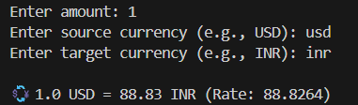

OBSERVATION:
The AI-generated script successfully fetches live currency conversion rates using a free API (https://api.exchangerate.host).

TASK – 2.2:
Add logic to retry the request up to three times if the API
call fails due to network or server issues and log all failed attempts
into a local error log file
PROMPT:
Extend the currency exchange script to retry the API request up to three times if it fails due to network or server issues. Log all failed attempts into a local error log file.

CODE GENERATED:
import requests
import time

def convert_currency(amount, from_currency, to_currency):
url = f"https://open.er-api.com/v6/latest/{from_currency.upper()}"
max_retries = 3
attempt = 0

while attempt < max_retries:
try:
response = requests.get(url, timeout=5)
if response.status_code == 200:
data = response.json()

if data.get("result") == "success":
rates = data.get("rates", {})
if to_currency.upper() in rates:
rate = rates[to_currency.upper()]
converted_amount = amount * rate
print(f"\n💱 {amount} {from_currency.upper()} = {converted_amount:.2f} {to_currency.upper()} (Rate: {rate:.4f})")
return
else:
print("❌ Invalid target currency code.")
return
else:
print("❌ Invalid currency code or API error.")
return
else:
raise requests.exceptions.RequestException(f"Server error: {response.status_code}")

except requests.exceptions.RequestException as e:
attempt += 1
with open("error_log.txt", "a") as log_file:
log_file.write(f"Attempt {attempt}: {str(e)}\n")
print(f"⚠️ Attempt {attempt} failed. Retrying...")
time.sleep(2)

print("❌ All attempts failed. Please check your internet connection or try later.")

# --- Main Program ---
try:
amount = float(input("Enter amount: "))
from_currency = input("Enter source currency (e.g., USD): ").upper()
to_currency = input("Enter target currency (e.g., INR): ").upper()
convert_currency(amount, from_currency, to_currency)

except ValueError:
print("❌ Invalid amount entered. Please enter a numeric value.")

OUTPUT:
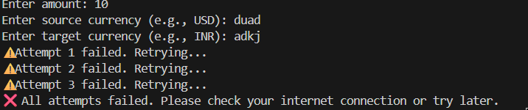
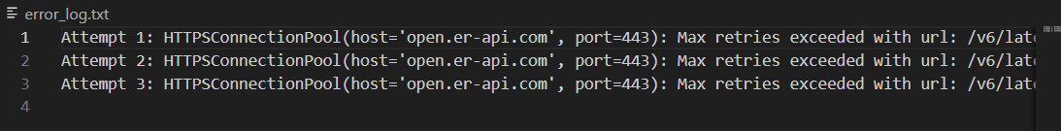

OBSERVATION:
The AI-generated script adds reliability by retrying the API request up to three times in case of failures.
All failed attempts are recorded in an error log file for troubleshooting, ensuring the program doesn’t crash during network or server issues.

TASK – 3.1:
News Headlines API
A news aggregator wants to display the latest technology news headlines
using a news API. Sometimes, the API responds slowly or returns
incomplete data.
Use AI-assisted coding to fetch the top 5 technology
headlines and print them neatly in the console. Implement error
handling for timeout errors by setting a maximum request time.

PROMPT:
Write a Python script (using AI assistance) to fetch the top 5 technology news headlines and print them neatly in the console. Handle timeout errors by setting a maximum request time.
CODE GENERATED:
import requests

def fetch_tech_news():
url = "https://saurav.tech/NewsAPI/top-headlines/category/technology/in.json"

try:
# Set timeout to 5 seconds
response = requests.get(url, timeout=5)
response.raise_for_status() # Raises an exception for HTTP errors

data = response.json()

# Check if data contains valid articles
if "articles" in data and len(data["articles"]) > 0:
print("\n📰 Top 5 Technology News Headlines:\n")
for i, article in enumerate(data["articles"][:5], start=1):
print(f"{i}. {article.get('title', 'No title available')}")
else:
print("⚠️ No articles found or incomplete data received.")

except requests.exceptions.Timeout:
print("❌ Request timed out! The server took too long to respond.")
except requests.exceptions.RequestException as e:
print(f"❌ An error occurred: {e}")

# --- Main Program ---
fetch_tech_news()

OUTPUT:
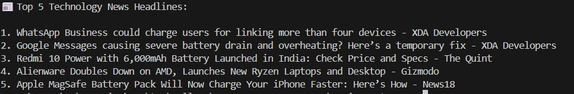

OBSERVATION:
The AI-generated script successfully fetches and displays the latest technology headlines from a public news API.

TASK 3.2:
Clean and preprocess the headlines by removing special characters and converting text to title case. Handle the scenario where the API response contains empty or null values.
PROMPT:
Extend the script to clean and preprocess the fetched headlines by removing special characters and converting them to title case. Handle cases where the API response contains empty or null values.
CODE GENERATED:
import requests
import re

def clean_headline(text):
"""Remove special characters and convert to title case."""
if not text or text.strip() == "":
return "No Title Available"
# Remove special characters except alphabets, numbers, and spaces
cleaned = re.sub(r'[^A-Za-z0-9\s]', '', text)
return cleaned.title().strip()

def fetch_and_clean_news():
url = "https://saurav.tech/NewsAPI/top-headlines/category/technology/in.json"

try:
response = requests.get(url, timeout=5)
response.raise_for_status()
data = response.json()

if "articles" in data and len(data["articles"]) > 0:
print("\n📰 Cleaned Top 5 Technology Headlines:\n")

for i, article in enumerate(data["articles"][:5], start=1):
raw_title = article.get("title", "")
clean_title = clean_headline(raw_title)
print(f"{i}. {clean_title}")

else:
print("⚠️ No valid articles found or incomplete data received.")

except requests.exceptions.Timeout:
print("❌ Request timed out! The server took too long to respond.")
except requests.exceptions.RequestException as e:
print(f"❌ An error occurred: {e}")

# --- Main Program ---
fetch_and_clean_news()

OUTPUT:
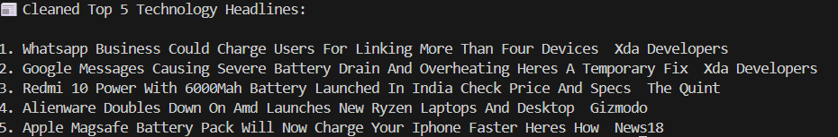
OBSERVATION:
The script fetches the latest technology headlines, removes unwanted special characters, and formats each title in Title Case.

